Tutorial for finding memory leak in VS2019

1. Include crtdbg.h in your main module



1. Add _CrtDumpMemoryLeaks(); right before return 0; of the main

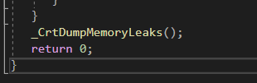

1. Run program with F5(debugging mode)
2. There may be these leak detection message in your VS Output window (not running console)

{147} normal block at 0x00A3E5E8, 10 bytes long.

Data: <Container > 43 6F 6E 74 61 69 6E 65 72 00

{145} normal block at 0x00A3E460, 10 bytes long.

Data: <Separator > 53 65 70 61 72 61 74 6F 72 00

{143} normal block at 0x00A3E230, 8 bytes long.

Data: <Bad one > 42 61 64 20 6F 6E 65 00

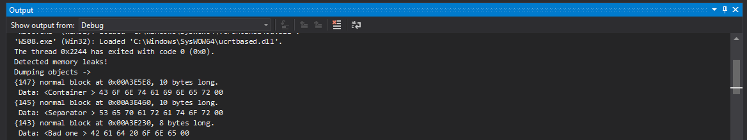

1. Above 147, 145, 143 means the address of the leaked memory.
2. Let’s add _CrtSetBreakAlloc(143); at the first of main function.

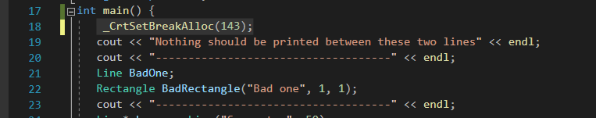

1. And if you run F5(debugging) again, it will break at the moment of leaked memory address ‘143’ is first allocated

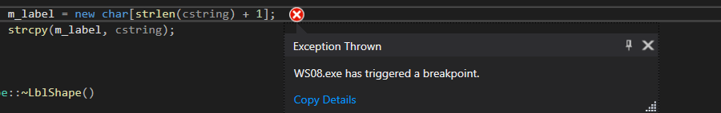

-Junwoo Lee